**AWS Service Cost calculator for the past usage**

1. **Usecase-1: Get the usage cost for the past 14 days only not before that.**

# Go to AWS Cost Management and click on cost explorer highlighted in yellow like below:

Go to Report Parameters on right and select the date range and granularity. If you select granularity to daily or hourly and use only selected operations for more granularity, you will see below dialogue box

Which shows that you cannot see in detail cost related to each operation. Same dialogue box will appear if you try to go beyond 14 days usage history.

1. **Usecase-2: Get the usage cost for any custom date range for any specific service as well.**

# Go to AWS Billing and click on cost & usage reports highlighted in yellow like below:

Go to AWS usage report like below and you will see next page where in you can select your desired service:

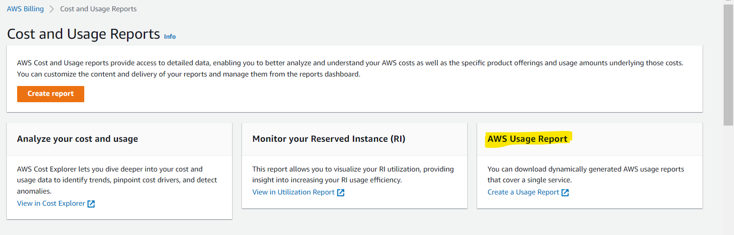

Once you click on this, below snippet can be seen:

Click on desired service on which you want to see its usage, lets suppose to check granular level usage of S3 service in terms of cost of Standrad Storage cost day/hour/month wise. Download the report in excel and view its content which will be somewhat similar to below:

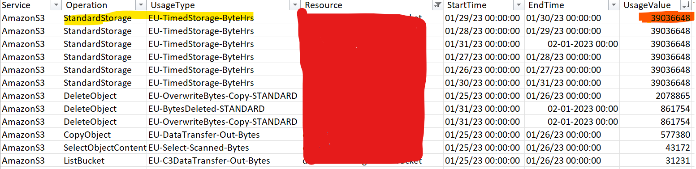

Above is day level granularity for S3 bucket and above is filtered on a specific bucket which is hidden for security reason:

**Jargon**:

**Service**: Amazon S3

**Operation**: S3 action type

**UsageType**: S3 action type detail

**Resource**: Bucket name

**Usagevalue**: Bytes transferred or used

So, for cost we need to calculate the cost by below formula:

For example to see cost for 1 month of data transfer estimated:

Pick the data range of one day which is last day of month and select standard storage to see its cost.

* Get the value of Usagevalue which is basically represented in bytes. (39036648)
* For this, S3 cost of standard storage is 0.023$ per GB per month for eu-west-1 region which can be found on AWS cost pricing site.
* Now, convert above bytes to GB like below:
  + 39036648/1073741824 ~ 0.03635571151GB
  + Divide this by 24hour as UsageType is in bytehours so,

0.03635571151/24~0.00151482131GB per day

So, cost would be 0.00151482131*0.023=**0.00003484089$**